Programming Assessment Test (PAT)

# Description

JewelSuite is a 3D reservoir modeling application for the Oil & Gas industry. The main functionality of this high tech application is building 3D reservoir models to calculate volumes of oil and gas. The screenshot shows a simple example model: 2 horizons (top & base) and a fluid contact (water is below the contact, oil & gas is above the contact).

One of the purposes of the JewelSuite application is to calculate the volumes of the oil and gas in place in a certain reservoir zone. In the above simple example model: the volume **between** the 2 horizons and **above** the fluid contact (also highlighted in the cross section below).

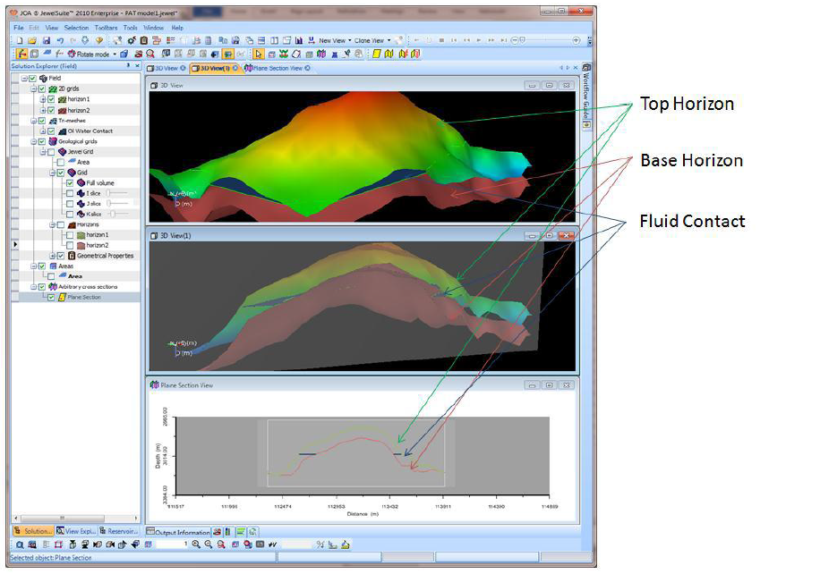

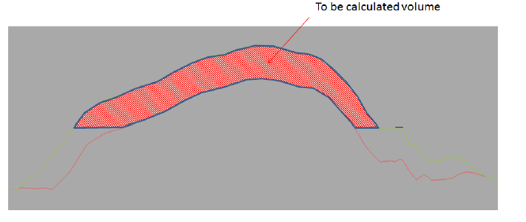

## The PAT

Write a **Windows WPF application** that calculates the volume of oil & gas between the 2 horizons and above the fluid contact. The user should be able to get the results in one of the following 3 units: cubic meter, cubic feet and barrels.

**The dataset**

The following data is available:

1. **Top Horizon: =** 2D regular grid format + depth value at every node

* Lateral dimension: 16 x 26
* Lateral grid cell sizes: 200 x 200 feet!
* The table below lists the 16x26 depth values of the top horizon (specified in feet) (see also separate attachment)

|  |  |  |  |  |  |  |  |  |  |  |  |  |  |  |  |
| --- | --- | --- | --- | --- | --- | --- | --- | --- | --- | --- | --- | --- | --- | --- | --- |
| 9911 | 9867 | 9824 | 9818 | 9767 | 9704 | 9691 | 9754 | 9843 | 10055 | 10082 | 10006 | 9865 | 9833 | 9842 | 9871 |
| 9889 | 9845 | 9804 | 9796 | 9746 | 9677 | 9644 | 9672 | 9753 | 9903 | 9998 | 9961 | 9854 | 10050 | 10039 | 10053 |
| 9845 | 9807 | 9792 | 9784 | 9732 | 9641 | 9580 | 9590 | 9639 | 9658 | 9757 | 9808 | 9824 | 10186 | 10421 | 10399 |
| 9811 | 9765 | 9747 | 9720 | 9625 | 9518 | 9498 | 9512 | 9570 | 9641 | 9679 | 9757 | 9782 | 10143 | 10464 | 10452 |
| 9786 | 9735 | 9698 | 9660 | 9549 | 9377 | 9381 | 9422 | 9491 | 9609 | 9677 | 9724 | 9761 | 10124 | 10417 | 10428 |
| 9776 | 9712 | 9656 | 9591 | 9472 | 9293 | 9320 | 9370 | 9437 | 9508 | 9588 | 9652 | 9734 | 10129 | 10409 | 10388 |
| 9749 | 9682 | 9606 | 9526 | 9401 | 9209 | 9227 | 9273 | 9367 | 9434 | 9507 | 9580 | 9688 | 10090 | 10412 | 10364 |
| 9698 | 9619 | 9532 | 9425 | 9305 | 9135 | 9100 | 9123 | 9188 | 9358 | 9451 | 9542 | 9645 | 10035 | 10354 | 10354 |
| 9714 | 9618 | 9525 | 9415 | 9211 | 9059 | 9047 | 9078 | 9115 | 9279 | 9409 | 9509 | 9604 | 9996 | 10316 | 10336 |
| 9765 | 9665 | 9570 | 9457 | 9245 | 8974 | 8996 | 9049 | 9135 | 9272 | 9395 | 9494 | 9563 | 9957 | 10281 | 10322 |
| 9805 | 9694 | 9594 | 9472 | 9207 | 8896 | 8926 | 9026 | 9119 | 9228 | 9347 | 9451 | 9529 | 9951 | 10270 | 10306 |
| 9982 | 9734 | 9616 | 9489 | 9217 | 8826 | 8860 | 8964 | 9106 | 9189 | 9290 | 9407 | 9499 | 9916 | 10268 | 10291 |
| 10066 | 9817 | 9697 | 9543 | 9266 | 8869 | 8904 | 8985 | 9113 | 9182 | 9262 | 9419 | 9656 | 9841 | 10176 | 10214 |
| 10078 | 9883 | 9758 | 9607 | 9327 | 8924 | 8965 | 9022 | 9118 | 9175 | 9238 | 9380 | 9702 | 9929 | 10085 | 10137 |
| 10118 | 9933 | 9778 | 9638 | 9373 | 9000 | 9062 | 9088 | 9140 | 9149 | 9194 | 9319 | 9653 | 9868 | 10017 | 10069 |
| 10120 | 9979 | 9811 | 9685 | 9460 | 9104 | 9144 | 9150 | 9153 | 9127 | 9171 | 9281 | 9616 | 9809 | 9958 | 10013 |
| 10115 | 9987 | 9853 | 9743 | 9532 | 9234 | 9245 | 9229 | 9186 | 9091 | 9130 | 9262 | 9596 | 9771 | 9893 | 9966 |
| 10172 | 10067 | 9949 | 9863 | 9624 | 9323 | 9283 | 9237 | 9185 | 9103 | 9126 | 9274 | 9627 | 9786 | 9898 | 9972 |
| 10211 | 10146 | 10060 | 9969 | 9759 | 9404 | 9333 | 9256 | 9178 | 9109 | 9139 | 9288 | 9667 | 9827 | 9921 | 9992 |
| 10302 | 10259 | 10200 | 9803 | 9717 | 9463 | 9389 | 9331 | 9268 | 9243 | 9263 | 9413 | 9804 | 9866 | 9935 | 9980 |
| 10313 | 10264 | 10235 | 9916 | 9654 | 9560 | 9493 | 9435 | 9396 | 9390 | 9410 | 9530 | 9927 | 9997 | 9972 | 9993 |
| 10316 | 10216 | 10035 | 10013 | 9812 | 9736 | 9701 | 9647 | 9611 | 9627 | 9615 | 9708 | 10032 | 10110 | 10082 | 10046 |
| 10360 | 10239 | 9986 | 9956 | 9964 | 9904 | 9900 | 9904 | 9883 | 9928 | 9842 | 9876 | 10157 | 10200 | 10179 | 10122 |
| 10383 | 10278 | 10040 | 10014 | 10029 | 10057 | 10099 | 10134 | 10179 | 10285 | 10168 | 10095 | 10271 | 10295 | 10255 | 10202 |
| 10252 | 10251 | 10076 | 10079 | 10105 | 10156 | 10219 | 10236 | 10293 | 10399 | 10315 | 10205 | 10367 | 10363 | 10320 | 10270 |
| 10287 | 10094 | 10097 | 10123 | 10170 | 10235 | 10312 | 10342 | 10351 | 10457 | 10377 | 10292 | 10436 | 10424 | 10374 | 10330 |

2. **Base Horizon** = Top Horizon + 100 meter

3. **Fluid contact** = 3000 meter

## PAT Success criteria

The PAT success criteria are:

1. Coding style / Efficiency
2. Quality:
   1. Correctness of results (e.g. correct volume calculated in all 3 units)
   2. Usability (UI & feel)
   3. Maintainability
   4. Reliability
   5. Extensibility
3. The solution must be written in C#, using either VS2015 or VS2017. It shall be one submitted as a zip file.